Oli Safe Care Database Design
Participants
Customer- Lior Sheiner
Designer- Noa Akerman
Reviewer- Matan Dan On

Organization and Main Use Case: Oli Safe Care
Oli Safe Care is an Israeli skincare company that sells pregnancy, postpartum, and baby care products through its online store.. It also supports future expansion to external retail stores such as Shilav.

Customer Requirements and Justification
1. Customer Management- The system should store customer details and order history.
2. Product Catalog-The system should store product information including category, description, selling price, and product cost.
3. Inventory Management- The system should track inventory quantities and inventory costs.
Justification: Inventory tracking helps prevent stock shortages, supports restocking decisions, and contributes to profitability calculations.
4. Order Management- The system should create and manage customer orders, including products, quantities, discounts, order status, and shipment information.
5. Shipping and Pickup Management- The system should store shipping and self-pickup information, including addresses, fulfillment method, delivery status, and shipping fees.
Justification: Customers can choose home delivery or self-pickup, so the company must track different fulfillment methods and delivery statuses.
6. Coupons and Influencer Discount Codes- The system should support discount coupons and influencer codes and track their usage in customer orders.
Justification: The company uses influencer collaborations and coupon campaigns as part of its marketing strategy and needs to track their performance.
7. Business Expenses and Profit Tracking- The system should record monthly business expenses such as packaging, shipping, marketing, and other operational costs.
8. External Retail Store Management- The system should support future inventory tracking and restocking for external retail stores such as Shilav branches.
Justification: Expansion to retail stores is expected in the coming months, so the system should be prepared from the start to manage inventory across multiple locations.

Designer Understanding of the Use Case and Suggested Improvements
As the designer, I understand that Oli Safe Care needs a database system to manage customers, products, inventory, orders, deliveries, coupons, and business expenses. The system should support daily operations, sales tracking, marketing activities, profitability analysis, and future expansion to external retail stores.

Reviewers’ Notes Ahead of System Development
While the proposed database design fits the customer requirements, the reviewer suggested several simplifications.
Improvement 1: Simplifying Influencer Coupon Management
Requirement: Track coupon campaigns and influencer-related sales.
Critique: Separate influencer and coupon structures seemed unnecessarily complex.
Action: Store influencer information directly with coupon information.
Improvement 2: Supporting Flexible Order Management
Requirement: Support orders containing multiple products and quantities.
Critique: Orders require a flexible structure for managing multiple products.
Action: Support multi-product orders while keeping information organized.
Improvement 3: Simplifying Customer Address Information
Requirement: Store customer address information for deliveries.
Critique: A separate cities table may be unnecessary.
Action: The final design stores the city directly in customer and delivery records instead of using a separate cities table. Since deliveries are managed by the shipping company using city and address information, a separate city management structure is not currently necessary.

Discussion 1: Product and Inventory Management
Reviewer's Concern: The requirements focused on products and inventory quantities. Following the YAGNI principle, implementing a complex multi-store inventory system too early could add unnecessary complexity.
Customer’s Counter: store sales are planned in the relatively near future.
Agreed Improvement: The system will separate products, inventory locations, and inventory quantities, providing support for future retail expansion without introducing unnecessary complexity at the current stage.
Discussion 2: Coupons and Influencer Codes
Designer’s Concern: The requirements did not clearly distinguish between regular coupons and influencer campaigns.
Customer’s Counter: The company wants to track influencer campaign performance and commissions.
Agreed Improvement: The system will store coupon information together with influencer-related fields to support campaign tracking and analysis.

Discussion 3: Profitability and Business Reports
Designer’s Concern: Revenue information alone is not sufficient for profitability analysis.
Customer’s Counter: Management needs a simple way to compare income and expenses.
Agreed Improvement: The system will support basic profitability tracking using product, shipping, packaging (the default will be set as 8 shekels as this is the average package cost), and operational costs. Since the business is still in its early stages, the financial structure remains relatively simple. There are no salary or rent expenses at the moment.

Final Agreed System Design & Scope
The final database includes separate tables for customers, products, inventory, orders, deliveries, coupons, expenses, and future retail store management. The tables are linked through primary and foreign keys, and the full structure is presented in the schema diagram.
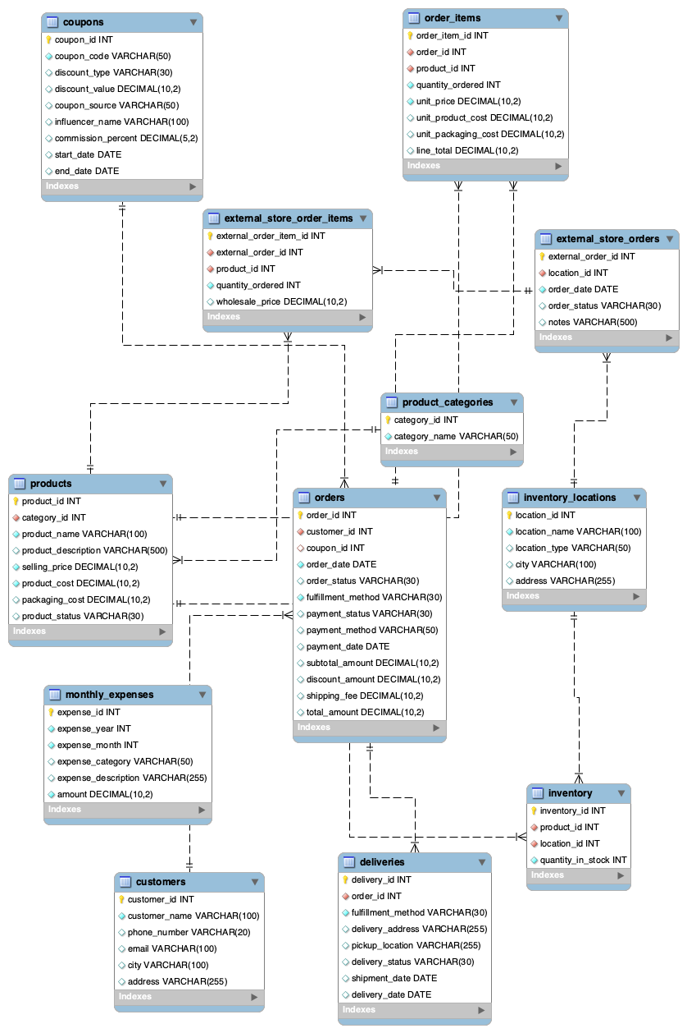
Reviewer Summary
As the reviewer, I verified that the final database design meets the customer requirements and fits the current business scale. The recommendations focused on keeping the system simple while supporting practical future growth. The final design balances current needs with future expansion and maintains an organized database structure.

